Strings in Java

Assignment

Question 1. What is a string in Java ?

Ans-

A string is an object that represents a sequence of characters. A string can be a single character or a sequence of characters, and it is always enclosed within double quotes.

For example, “hell world” is a string in Java that represents the sequence of characters”hello world”. Strings are used extensively in Java programs for storing and manipulating text-based data.

String in Java are immutable, which means that once a string object is created, its value cannot be changed. However, you can create new string objects based on the original string by using various methods, such as concatenation, substring, and replace.

Java provides a built- in String class that contains a wide range of methods for working with string, such as finding the length of a string, comparing string, converting springs to upper or lowercase, and more.

Question 2- Types of string in Java are ?

Ans-

In Java, there are two types of strings:

1. String literals: A string literal is a sequence of characters enclosed in double quotes. For example, “Hello,World!” is a string literals are created at compile time and are immutable.
2. String objects: A string object is an instance of the String class. String objects are created at runtime and can be manipulated using various methods provided by the String class. String objects are also immutable, meaning that once a string object is created, its value cannot be changed.

Here’s an example of creating a string object:



In addition, Java provides several other classes for working with strings, including StringBuilder and StringBuffer, which are mutable and can be used to efficiently manipulate large strings.

Question 3- In how many ways can you create string objects in Java?

Ans-

There are several ways to create string objects, including:

1. String literal: You can create a string object by enclosing a sequence of characters in double quotes. For example:

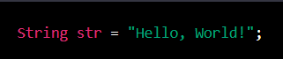

1. Using the String constructor: You can create a string object using the constructor of the String class. For example:



1. Using the StringBuilding class: You can create a string object using the StringBuilder class. This class allows you to manipulate strings in various ways, such as appending, inserting, and deleting characters.

For example:

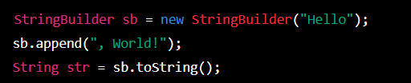

1. Using the StringBuffer class: The StringBuffer class is similar to StringBuilding,but it is synchronized, which makes it thread safe.

For example:

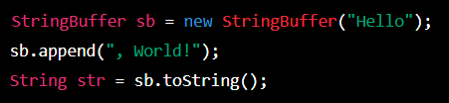

Finally, there are multiple ways to create string objects in Java depending on the specific use case and requirements.

Question 4- What is a string constant pool?

Ans-

The string consist pool is a special memory area where the Java Virtual Machine (JVM) stores a pool of unique string literals.

When a string literal is defined in the Java code, the JVM checks if the same string already exists in the string constant pool. If it does,then the reference to the existing string literal is used, instead of creating a new instance of the same string. This helps to save memory and improve performance.

For example:

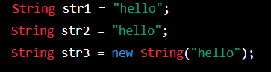

Question 5- What do you mean by mutable and immutable objects?

Ans-

Mutable objects can have their state modified after creation, while immutable objects cannot be modified after they are created. Examples of mutable objects include arrays and collections, while examples of immutable objects include the String and Integer classes. Immutable objects are thread-safe and less error-prone but can be less flexible.

Question 6- Where exactly is the string constant pool located in the memory?

Ans-

The string constant pool is a part of the method area, which is a shared area of memory used by all threads in a Java virtual machine (JVM). The method area is typically located in the heap, which is the region of memory allocation.

More specifically the string constant pool is located in the non-heap area of the memory called “PermGen” or “Metaspace” depending on the version of Java being used. In Java8 and earlier versions, the string constant pool is located in the PermGen (Permanent Generation) memory space, which is part of the Java heap. In JAva 9 and later versions, the PermGen space has been replaced by Metaspace, Which is also located outside of the heap.